*System Console Output*

SnowmanV2@3a6727

x is: 5

y is: 30

*Graphical Output*

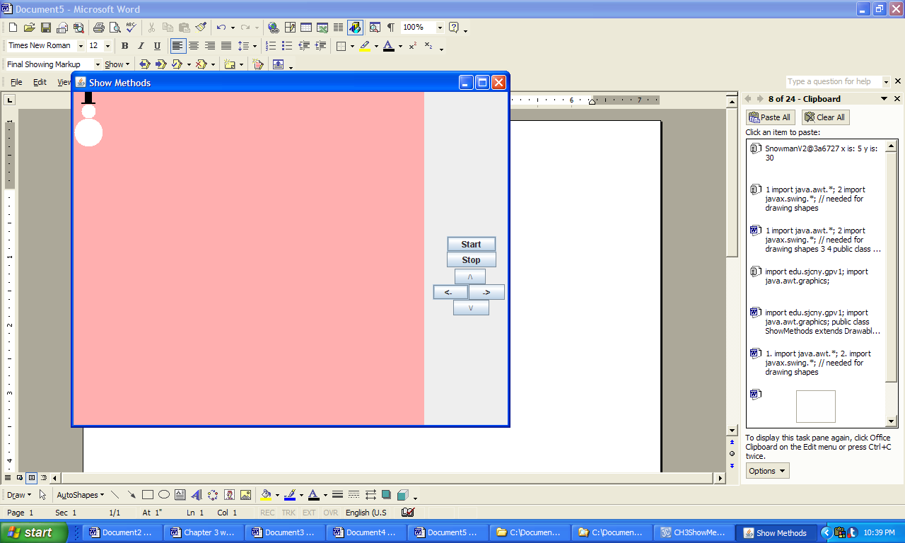

**Figure 3.22 The console and graphical output produced by the application ShowMethods.**